Project Name: School Management System
Course: 0714 02 CSE 2206
Course Name: Database Systems Project/Fieldwork

Course Teacher:
Mr. Aminul Islam
Assistant Professor,
Computer Science and Engineering Discipline
Khulna University, Khulna-9208

Developed By:
Md. Siam Ahmed (230202)
Md. Masrafi Murtoja (230207)
Sobuj Chandra Paul (230231)

General User Interface:
This interface can be used by any person. Here any person can see about school, teacher and staff information as well as student list. Anyone can apply for admission with appropriate information. They can show admission result of admission candidate and also show internal result of students. They can show events, achievements, notices and contact information.
Homepage: In homepage, shows navigation bar, message from headmaster and chairman and footer information. In navigation bar, also shows the latest notice. Everything fetches from database.

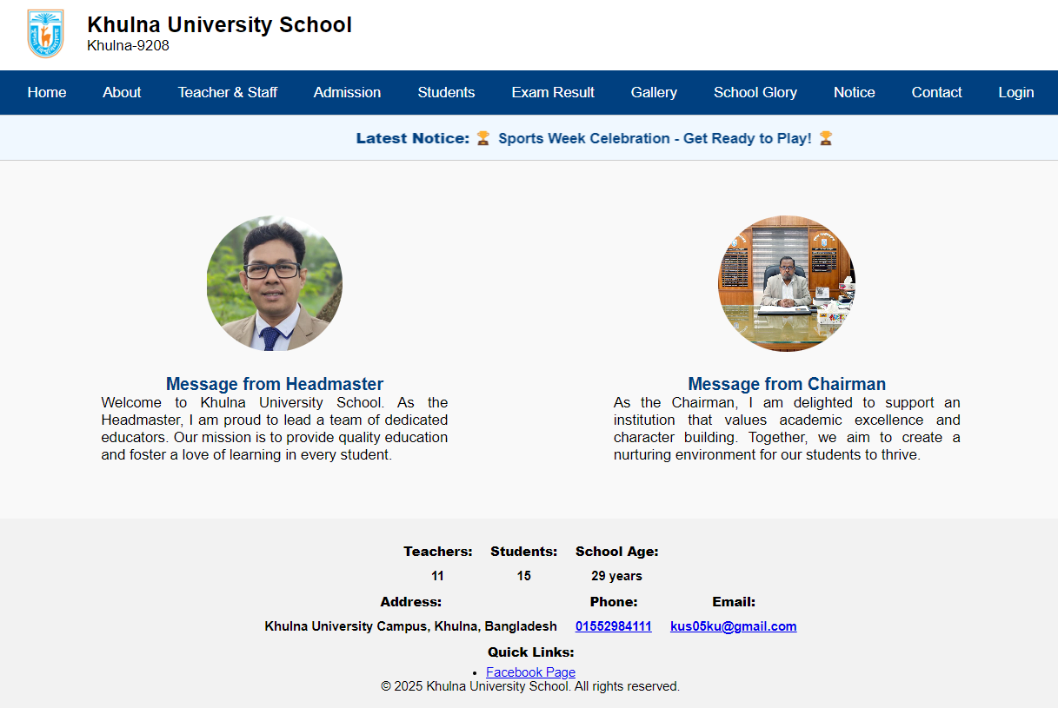

About: It has two Sub-Option.
- At a Glance: Shows a brief overview of the school which fetches from database.
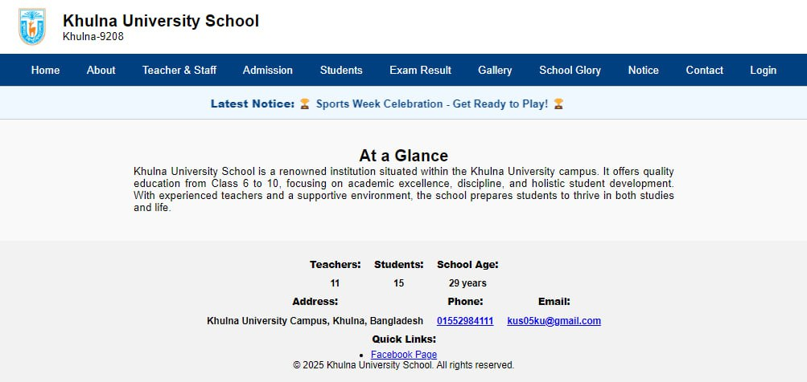

- History: Displays the history of the school in details which fetches from database.
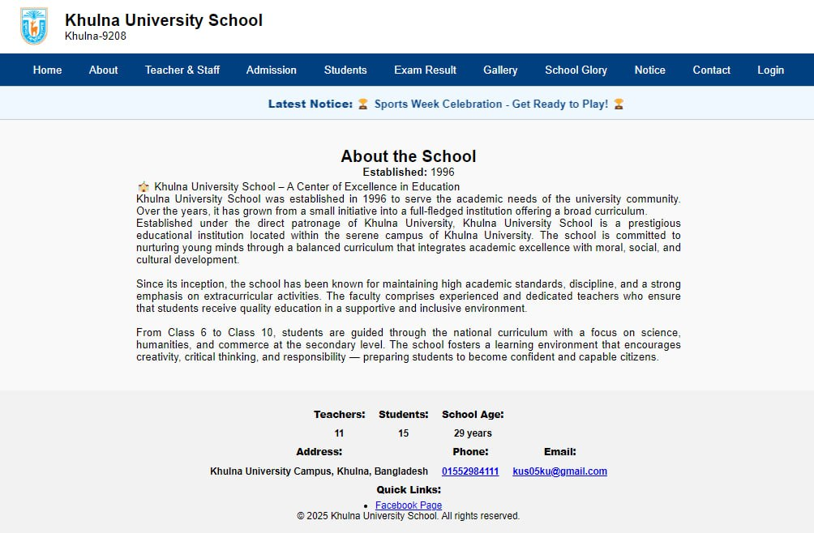
Teacher and Staff: Displays headmaster and assistant headmaster information, all working teachers, retired headmaster list, retired assistant headmaster list, all retired teachers with full details (name, designation, qualification, etc.) fetches from database.
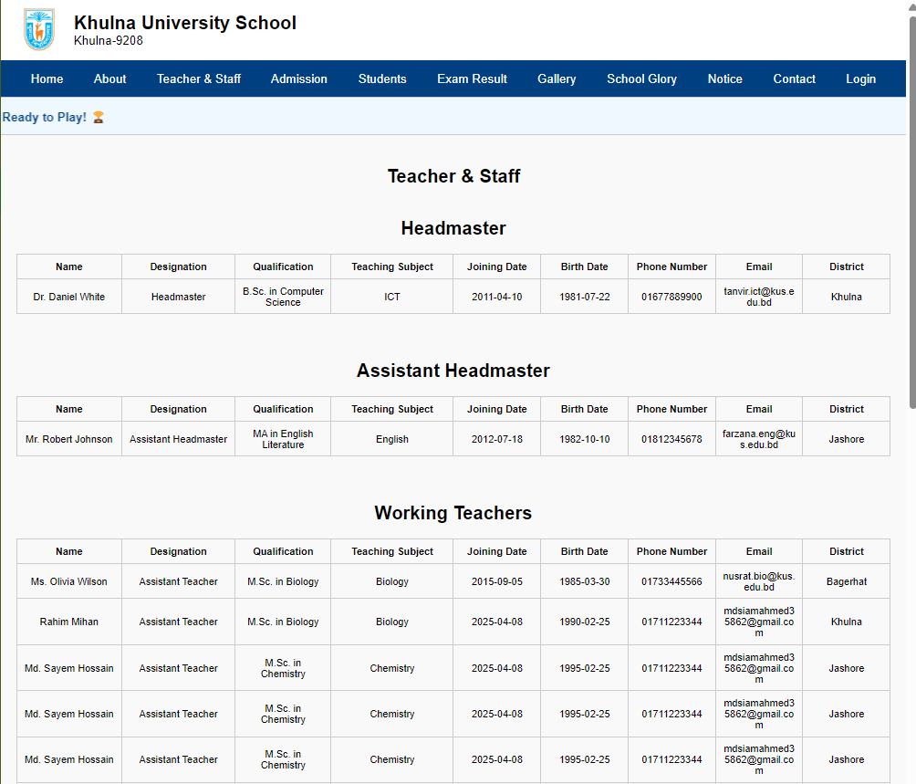
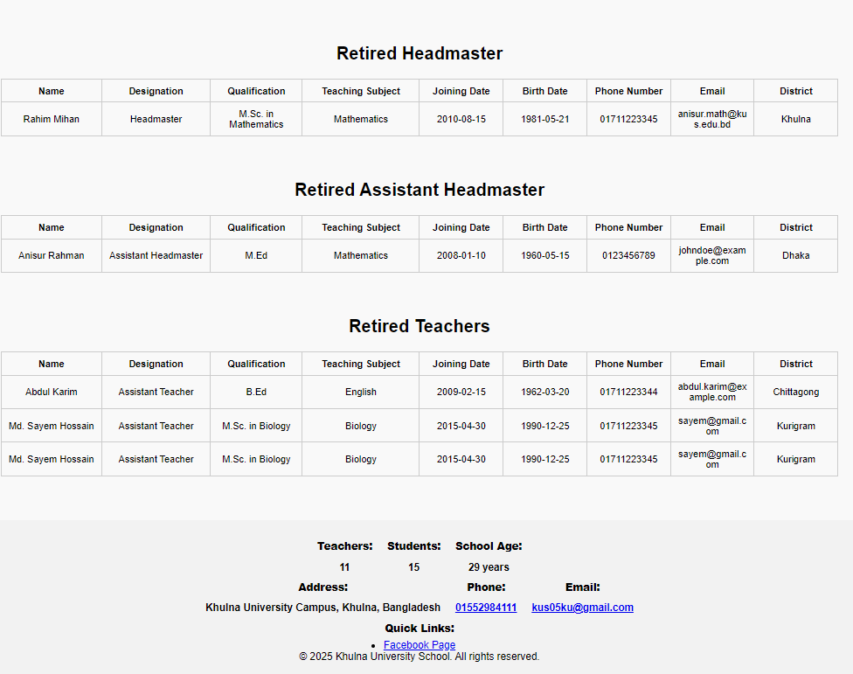Admission:
After clicking on apply now option, appears the admission form. An admission candidate can apply for admission by submitting the form with appropriate information.
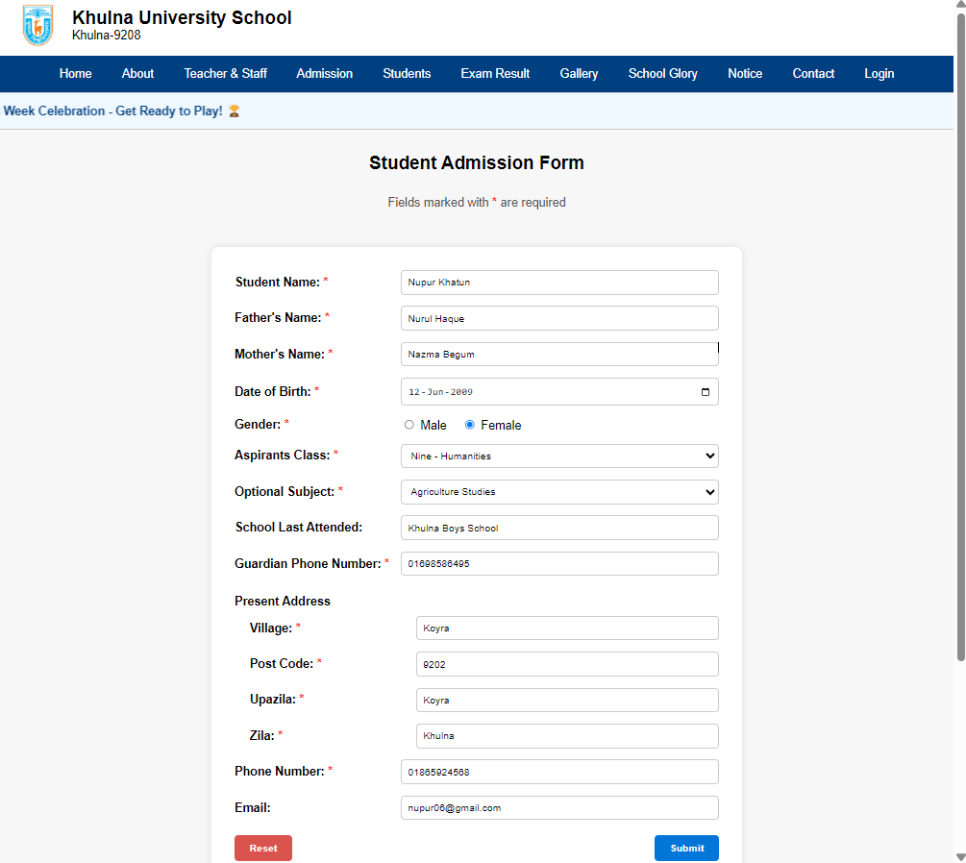
After submitting the form, a confirmation pop-up appears with applicant id. Also, all the information inserts into admission_form table of database.

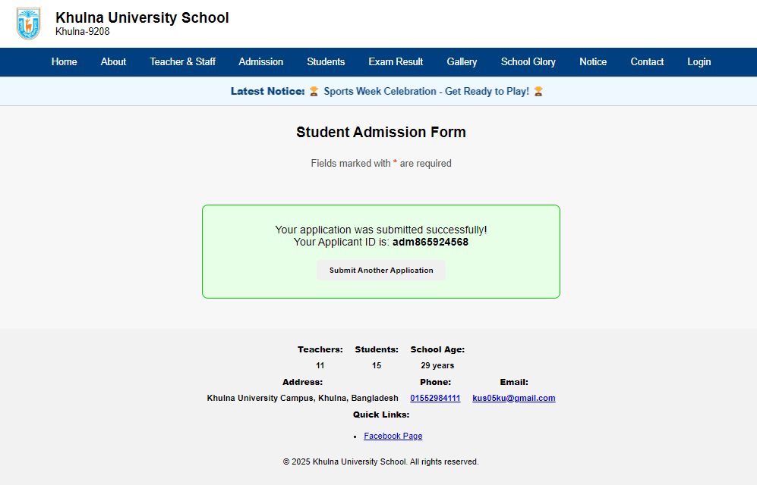
Students: It has three Sub-Option.
- Current Student Count: Displays the total number of student of the running academic year and shows the count of class and group.

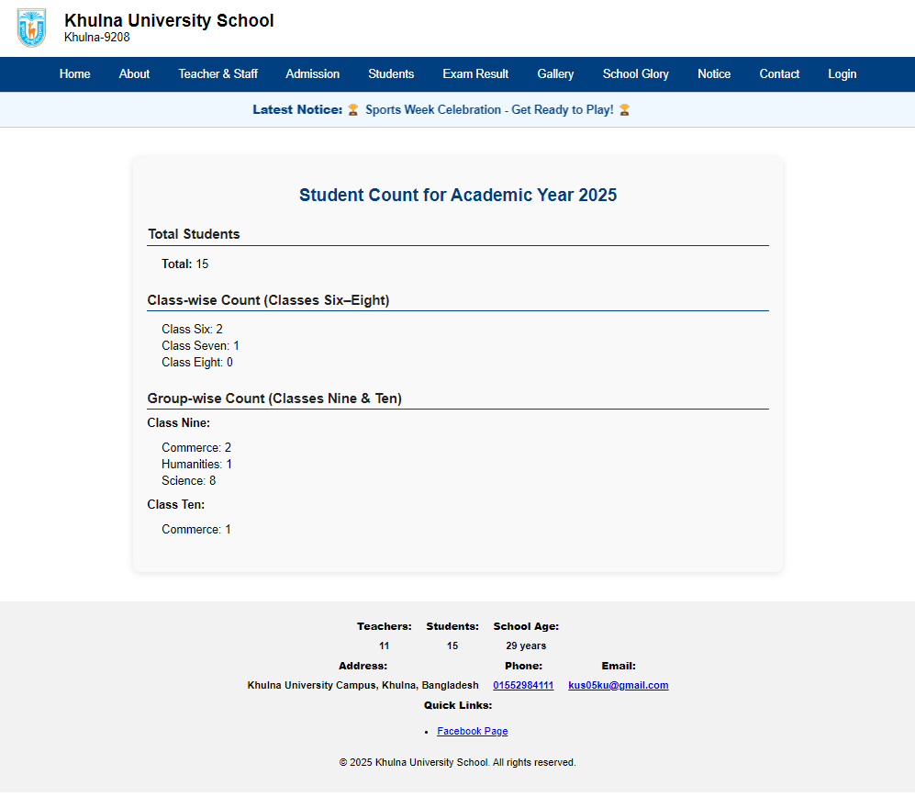
- Current Student List: Shows the current student list of selected class and group.

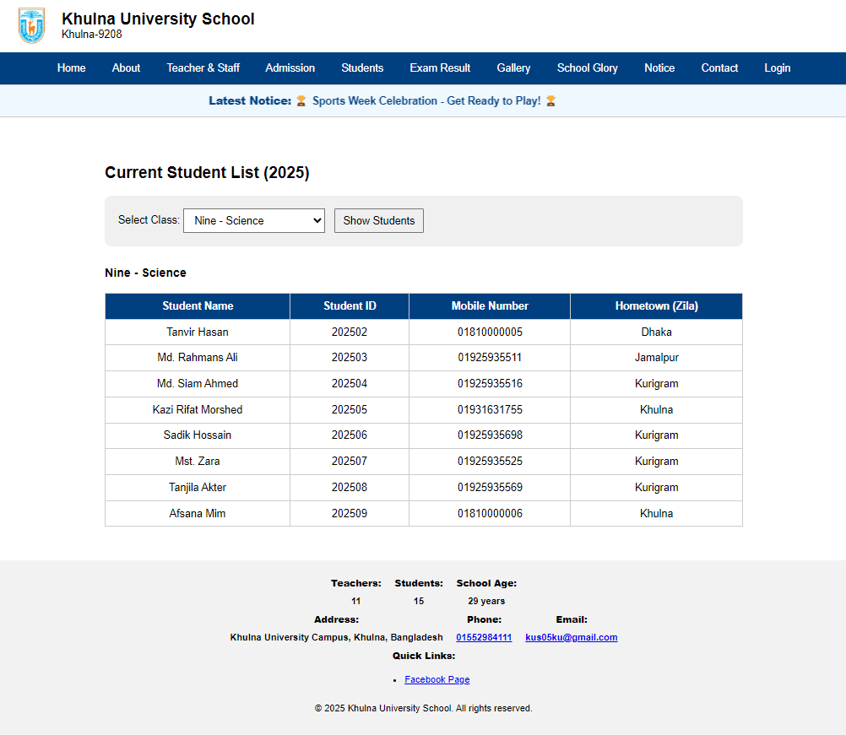
- Past Students List: See the past student list by selecting class, group and year.

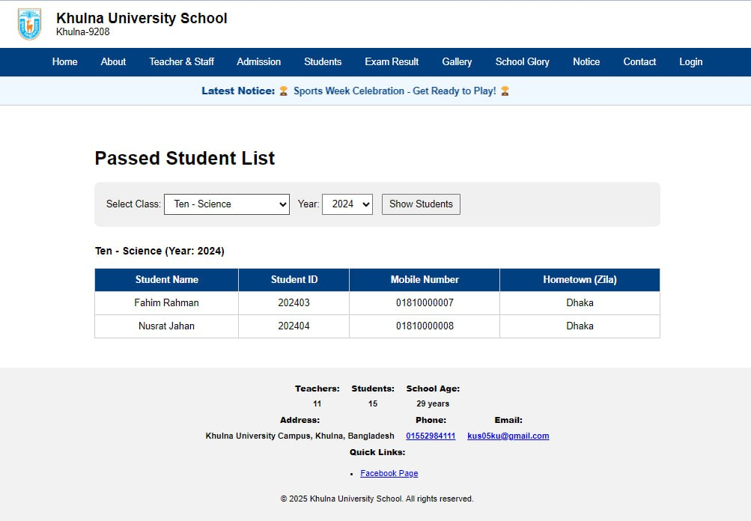
Exam Result: It has two Sub-options:
- Admission Result: Users fill in required information (e.g., Applicant ID, Name, etc.), and press upon submission button, the system displays the applicant’s admission result. The system find admission_id from admission_form table by using applicant_id and admission_year and date_of_birth. Then, it find result from admission_result table using admission_id. If not found then shows relevant message. If found ,would show the result.

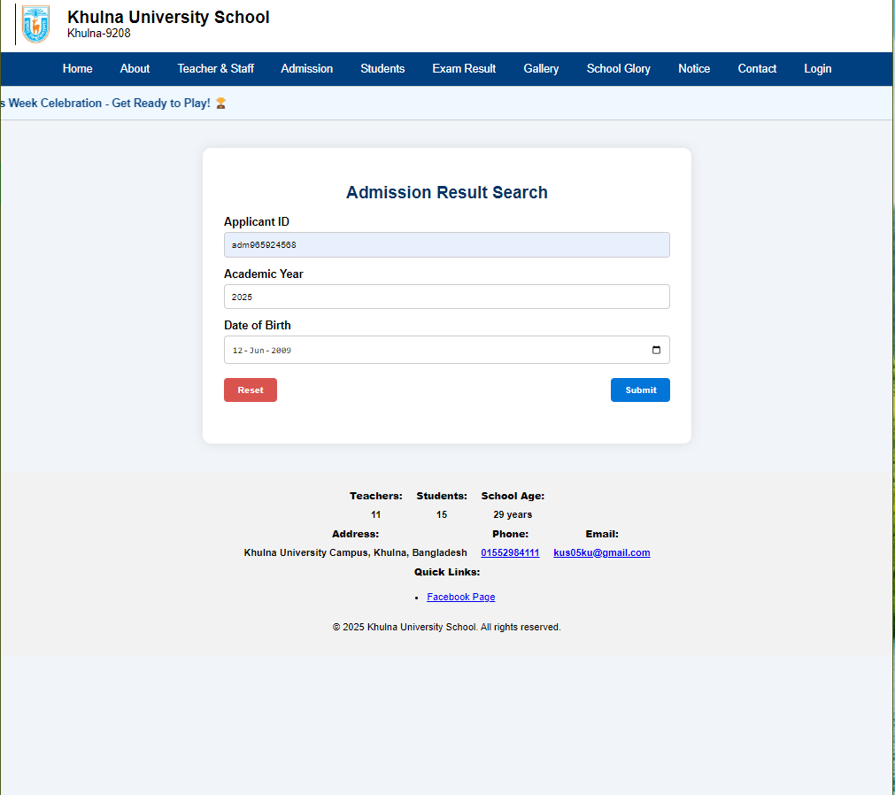
Shows admission result.
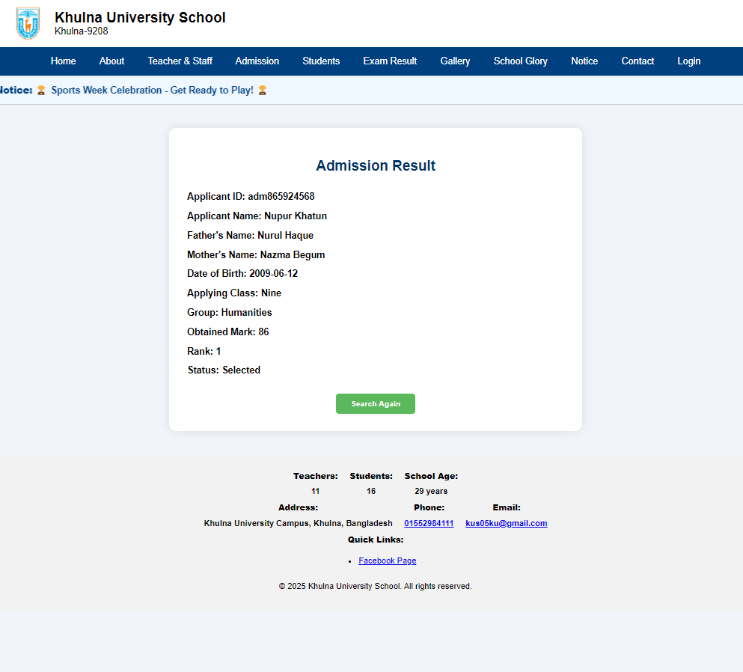
- Internal Result: A student can view his/her internal exam results by entering specific details such as Username, Class, Roll Number, and Password. After submitting the form, the result is shown. From his/her username and password the system finds st_ID from student_login table.
Then matches class and roll number. If does not match, show relevant message. If match,then calculate result and show. For calculation data fetches from student, class, marks, subject, student_subject etc. table.

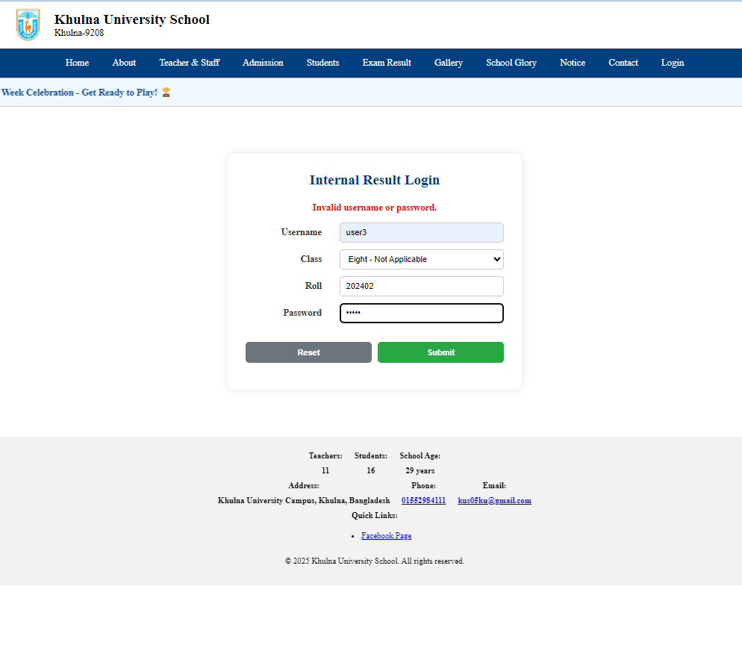
Marksheet with grade:
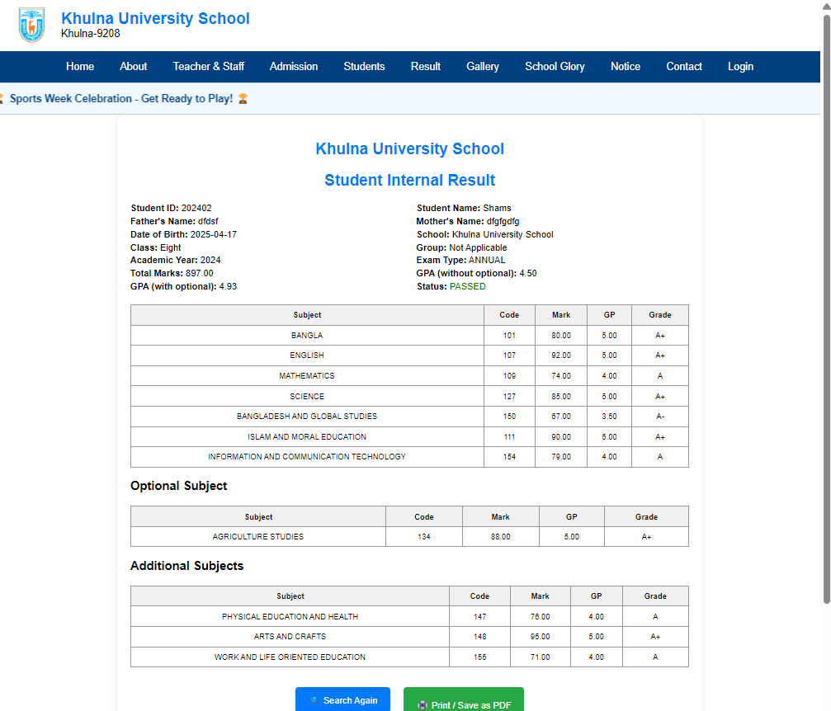

Gallery: It has two Sub-Option.
- Photos: Displays photo gallery of school events and activities fetches from gallery table of the database.
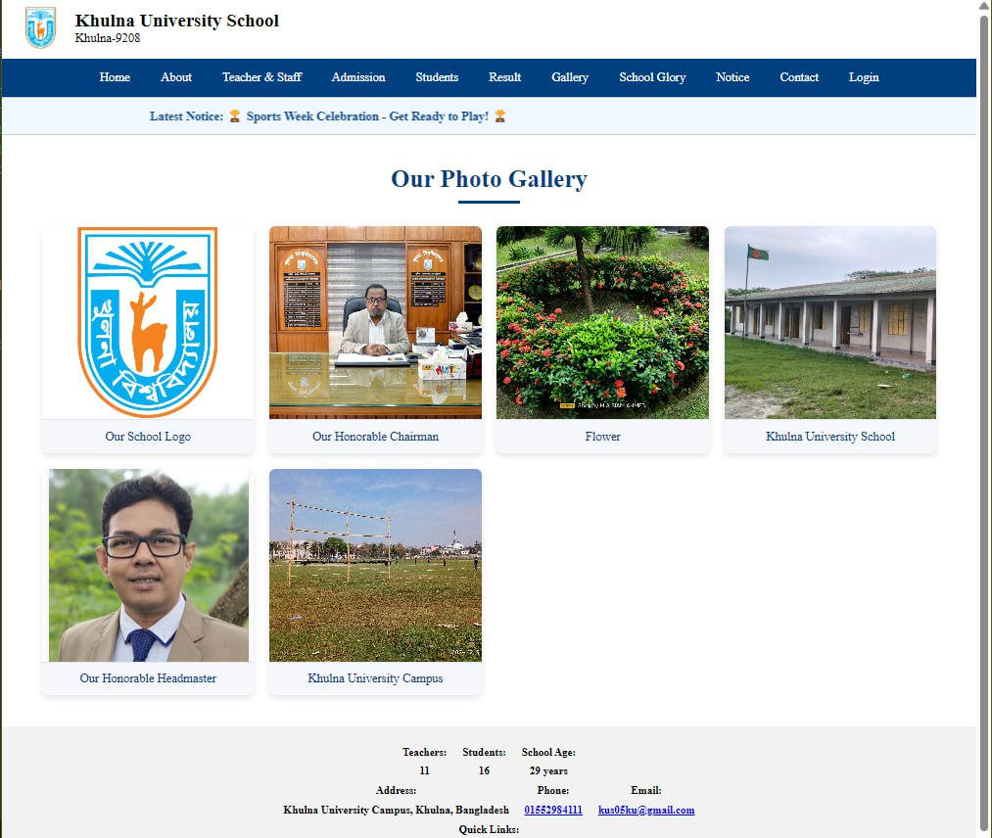

- Videos: Displays video gallery showcasing various events which fetches from gallery table of the database.
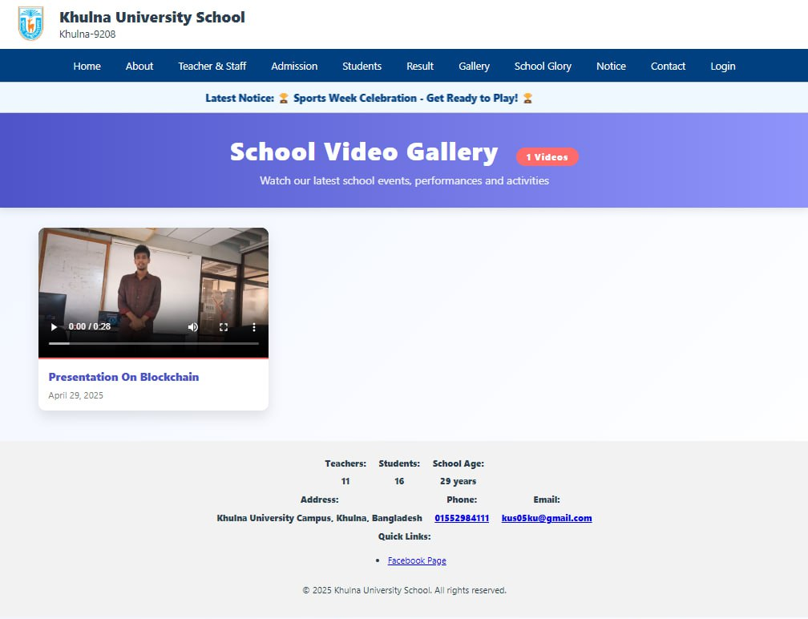
School Glory: It has two Sub-Option.
- Achievements: Dispalys the list of achievement, which is honored by student or teacher.
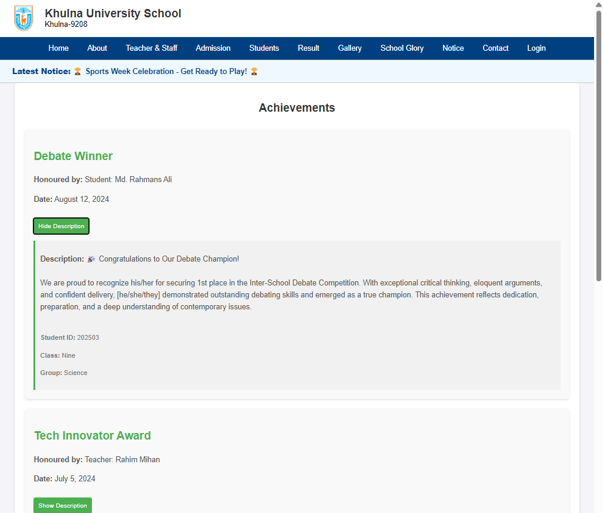

- Events: Shows the list of events which are organized or hosted by the school.
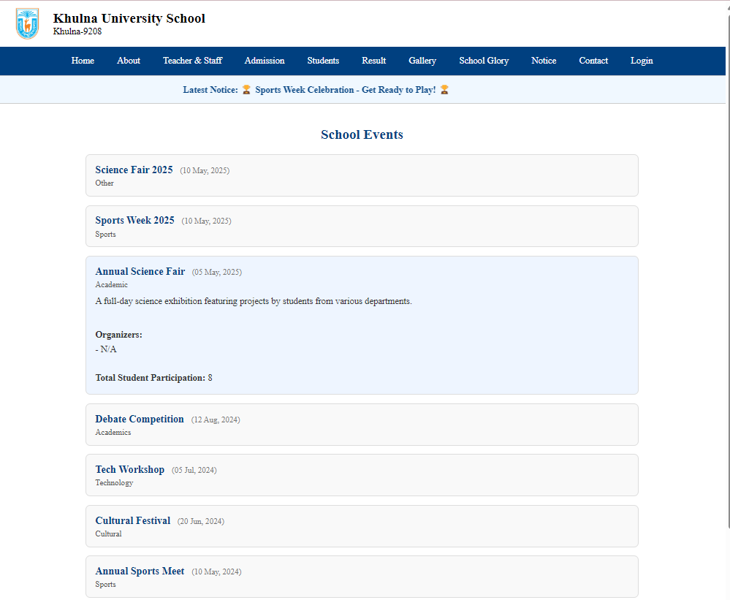
Notice: Displays all notices which fetch from notice table of the database.
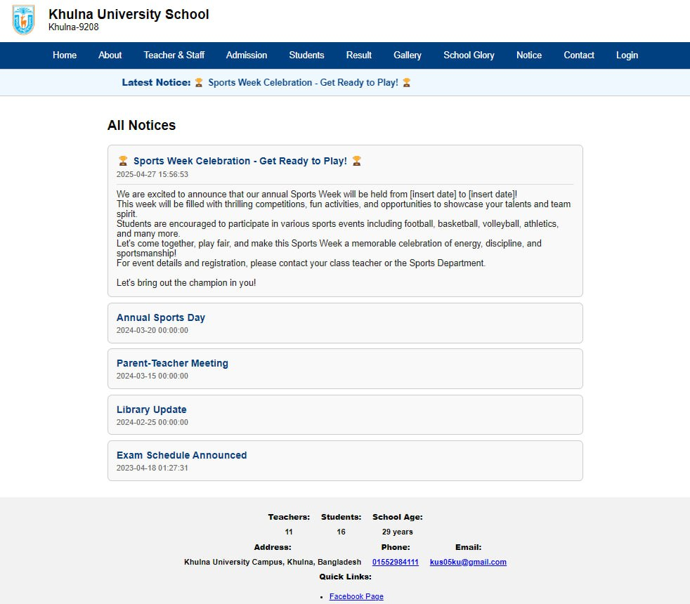

Student Interface:
This interface is specifically designed for students of the school. Students can log in using their credentials to access personalized information. After login, they can edit their Personal Information and login Credentials, view their Academic Information, view their attendance. Students can also view his Achievements and they can register an upcoming event.

Student Login: By submitting correct username and password, a student can login in his personal profile.

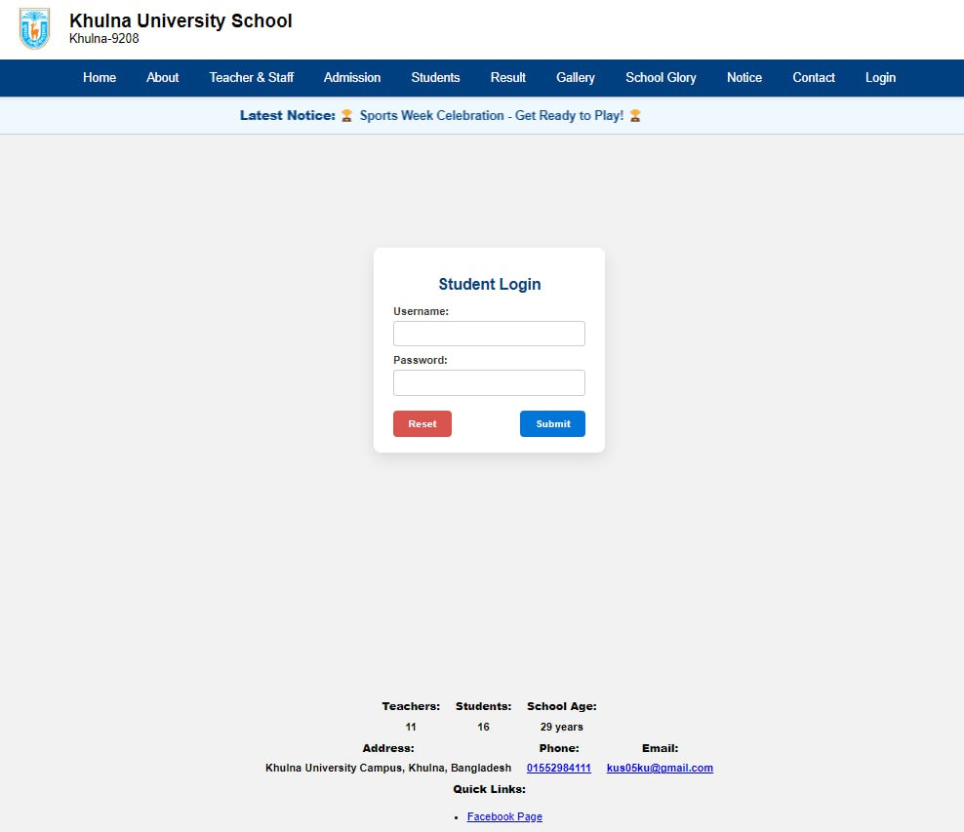

Here, shows student’s personal information and login credentials. A student can edit this information by clicking on edit button and then update button.
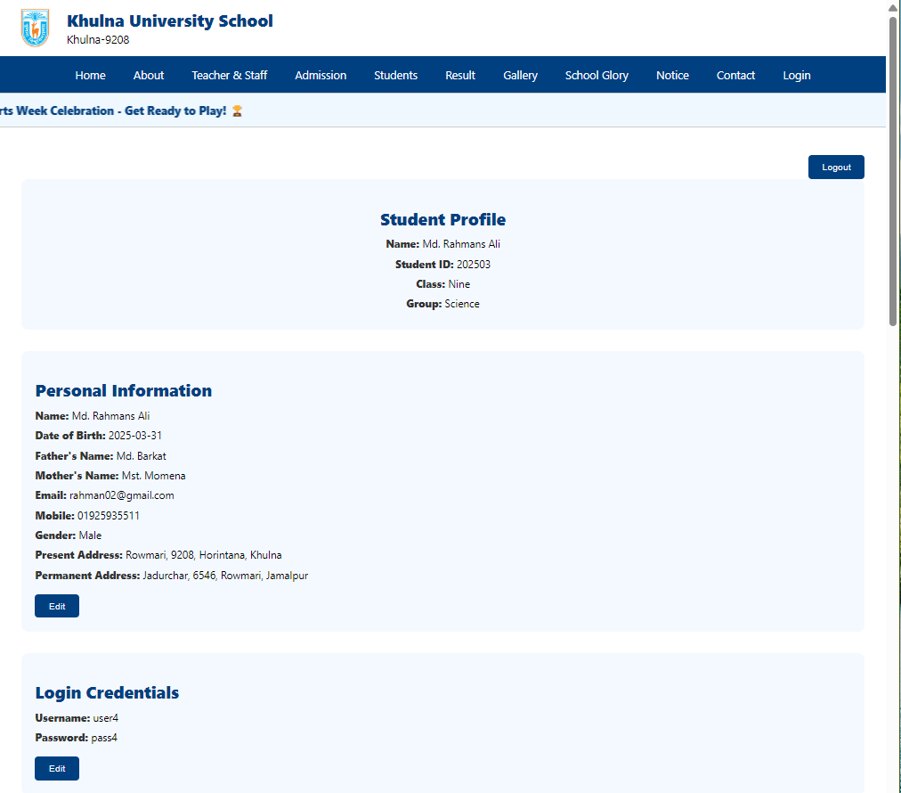
Here shows student’s academic information and attendance information.

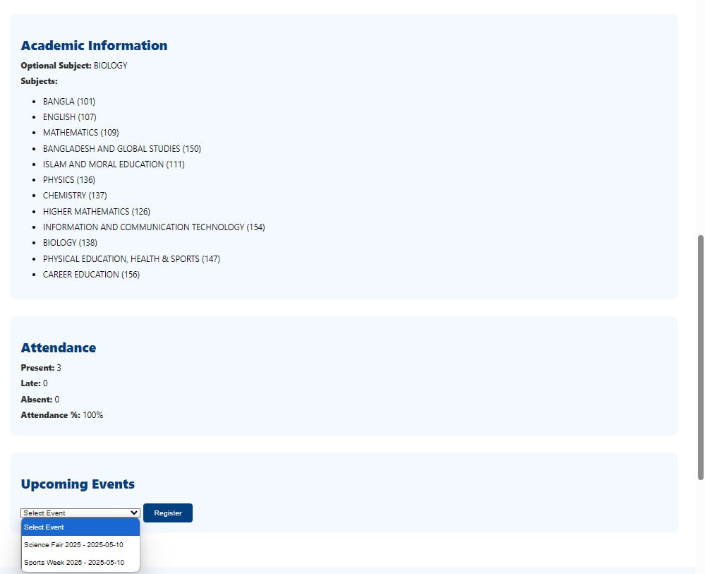

Here show upcoming events list. A student can register any events by clicking on register button. Also, the list achievement of his/her. And also, the list of events in which he participated or will participate.

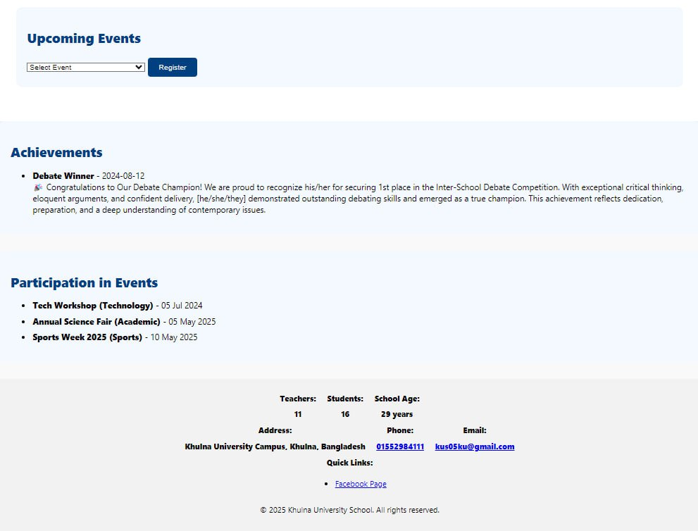

Teacher Interface:
This interface is intended for use by the teacher. After logging in with valid credentials, teachers can manage and enter student marks, record attendance to their classes. Teachers can organize events. The interface is structured to help teachers efficiently manage their academic responsibilities.

Teacher Login:

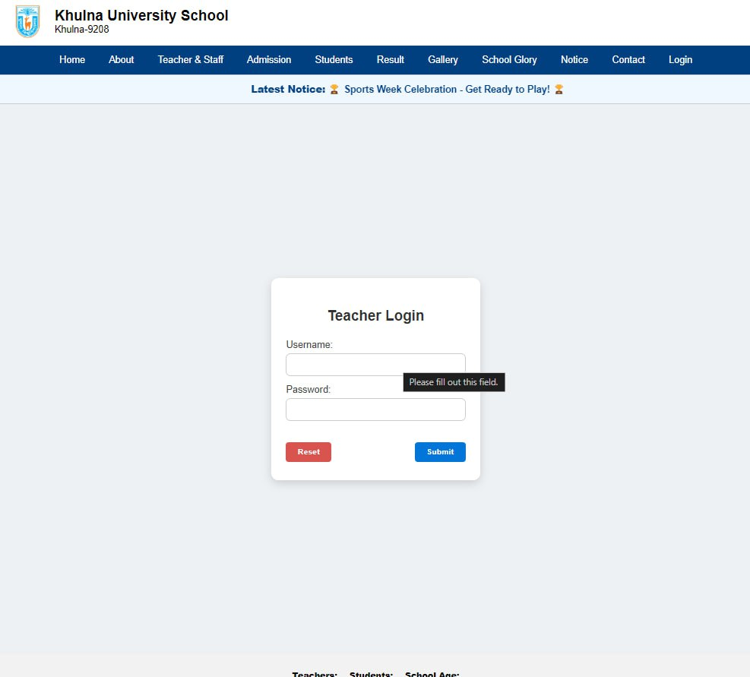

Here shows teacher’s information. Teacher can modify his personal information, login credentials, academic information. But he/she cannot update teaching information.
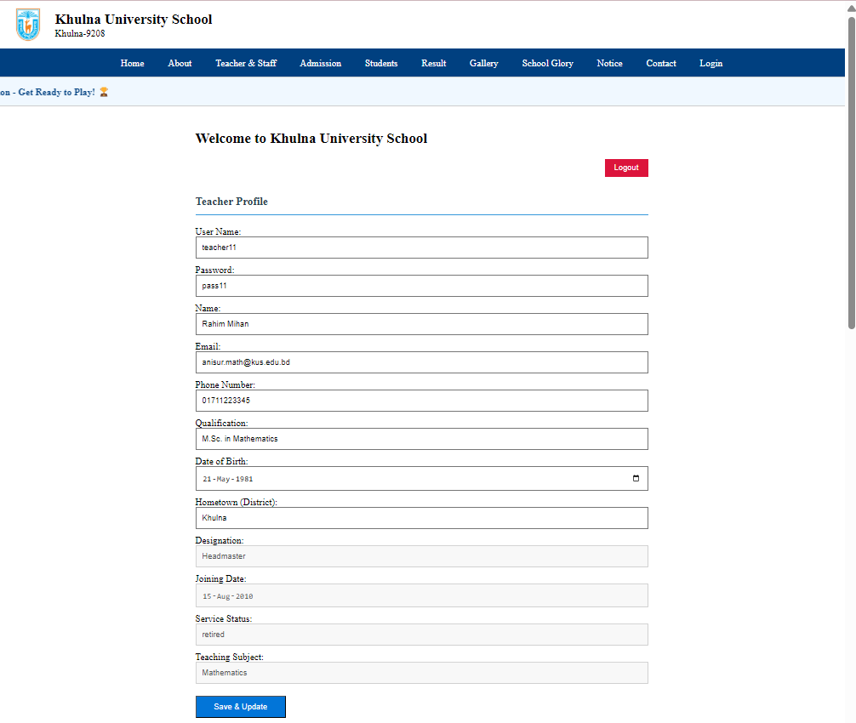

Here shows attendance entry form and marks entry form. A teacher can enter attendance and marks by filling proper information.

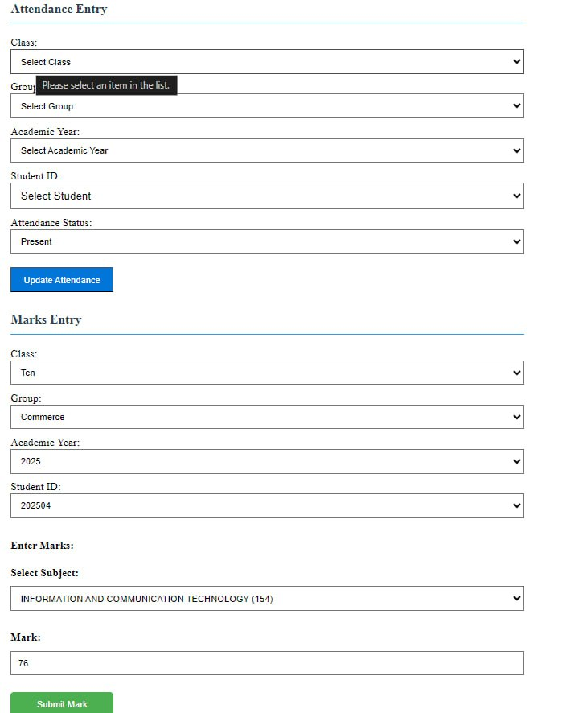
Here shows create event form. A teacher can organize an event by creating an event by filling this form properly. In below, show the list of events that the teacher organizes.

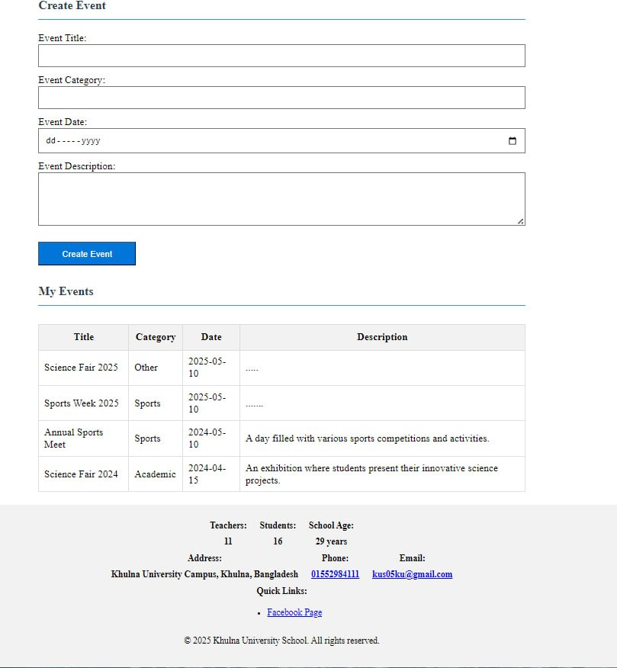

Admin Interface:
The Admin Interface is accessible only by the authorized school administrator. Through this interface, the admin can manage all aspects of the school website, including editing teacher and student information, updating admission data, uploading notices, and maintaining the gallery section. The admin has full control over the system’s content, ensuring the platform remains accurate, up-to-date, and secure.
Here shows school name, established year, brief history and history in detail. Which can be update by clicking on update school info. Then these will be updated.

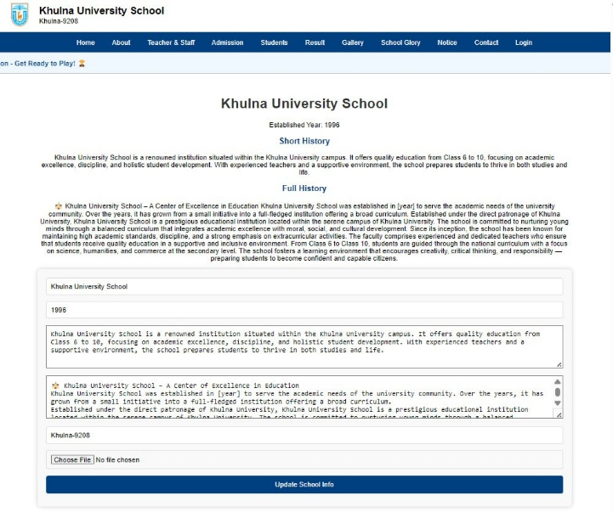
Here shows headmaster’s message and chairman’s which can be updated by clicking on update message button and also can update their photo by uploading photo.
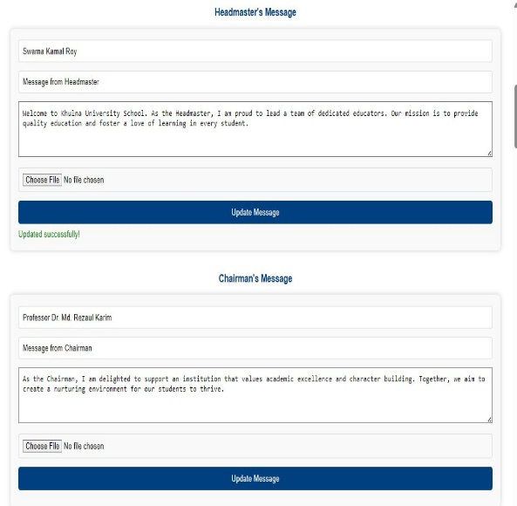

Here shows login info. An admin can update his login credentials. Here also, shows marks entry form and admission result entry form. An admin can entries marks and admission result by selecting proper option from the form and submit that.

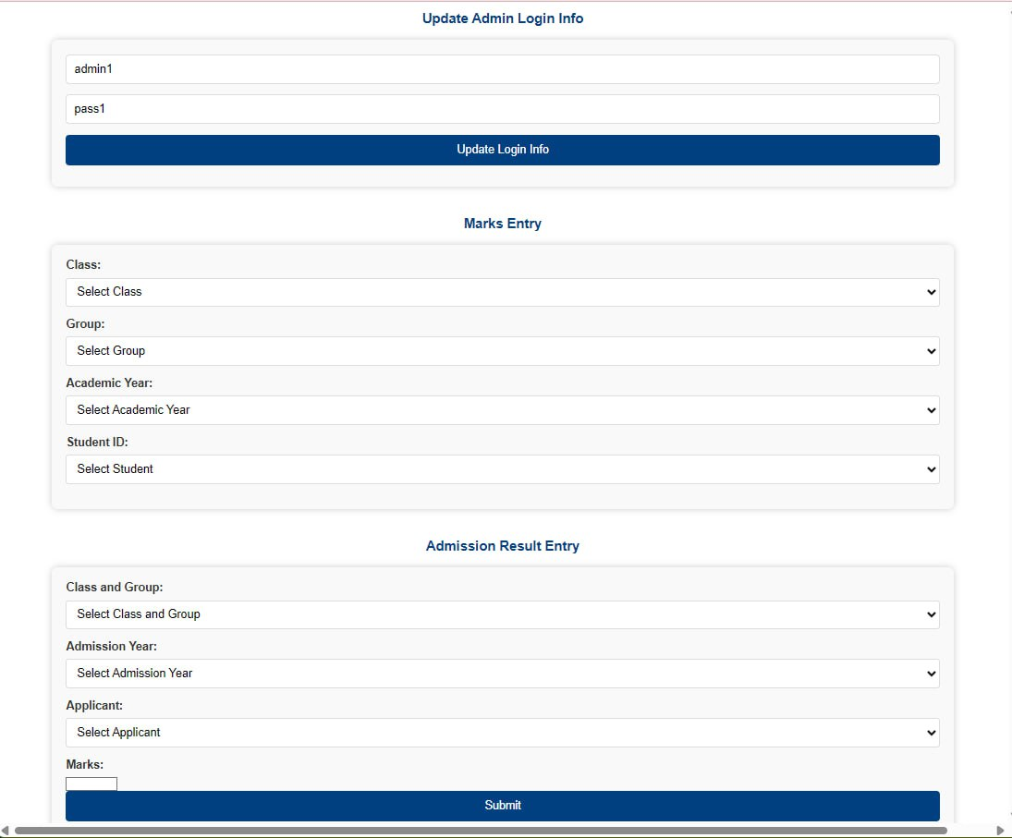
Here shows student admission process. An admin can admit a student clicking on admit button and also reject his/her.

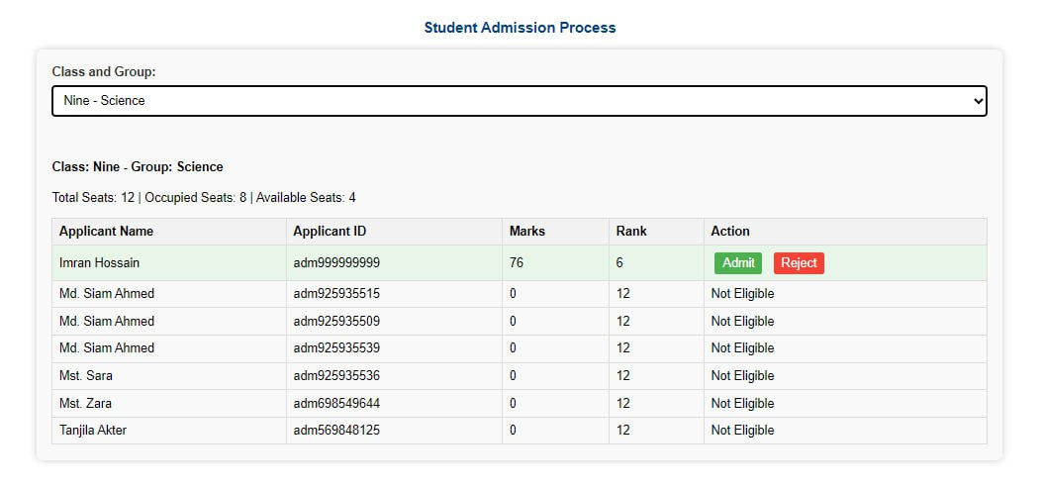

This is teacher management system. Here an admin can appoint a new teacher by filling the form with proper information.

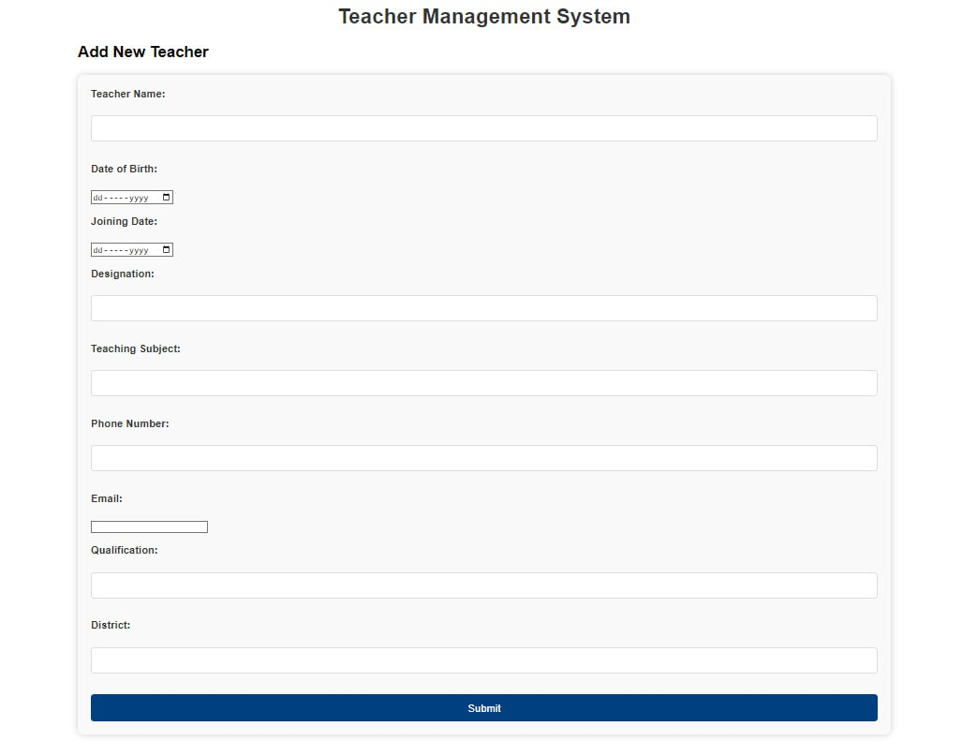

Here shows teacher list with edit action. An admin can edit teacher’s information after clicking on edit button.
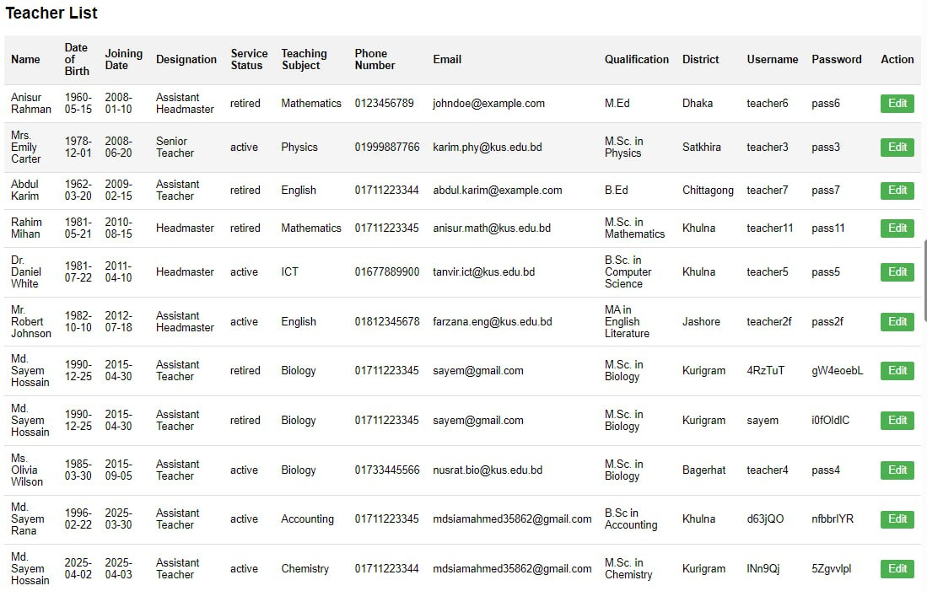
This is notice management section. Here an admin can add a new notice. Also, an admin can update or delete existing notice.
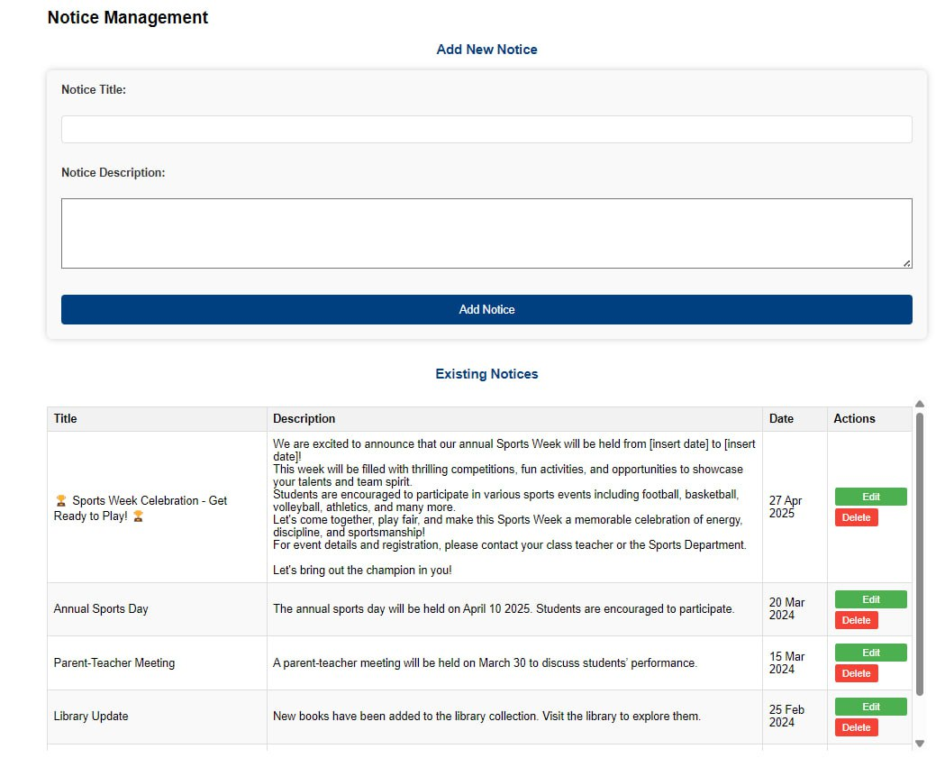
This is achievement management section. Here an admin can add a new achievement and edit or delete the existing achievement.

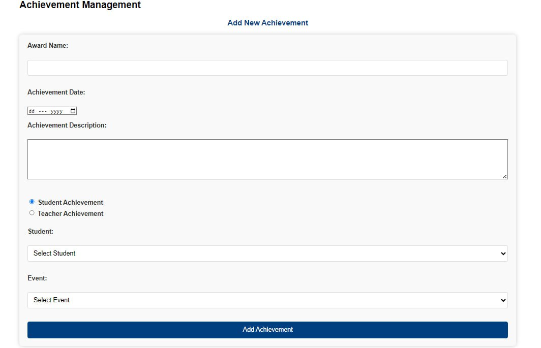

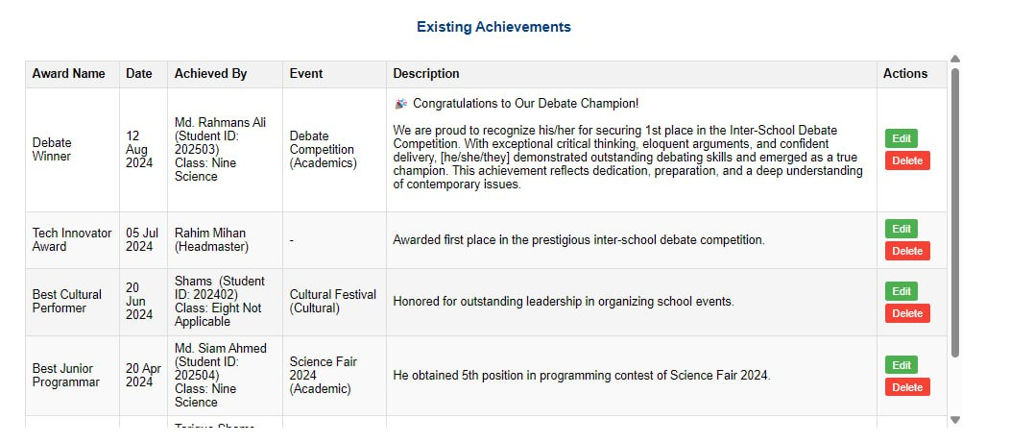

Here shows upload video or photos section for gallery section of general interface.

